**Lab Assignment – 2**

1. **Check firewall settings in your windows machine.**

In below images of inbound and outbound rules of the firewall.

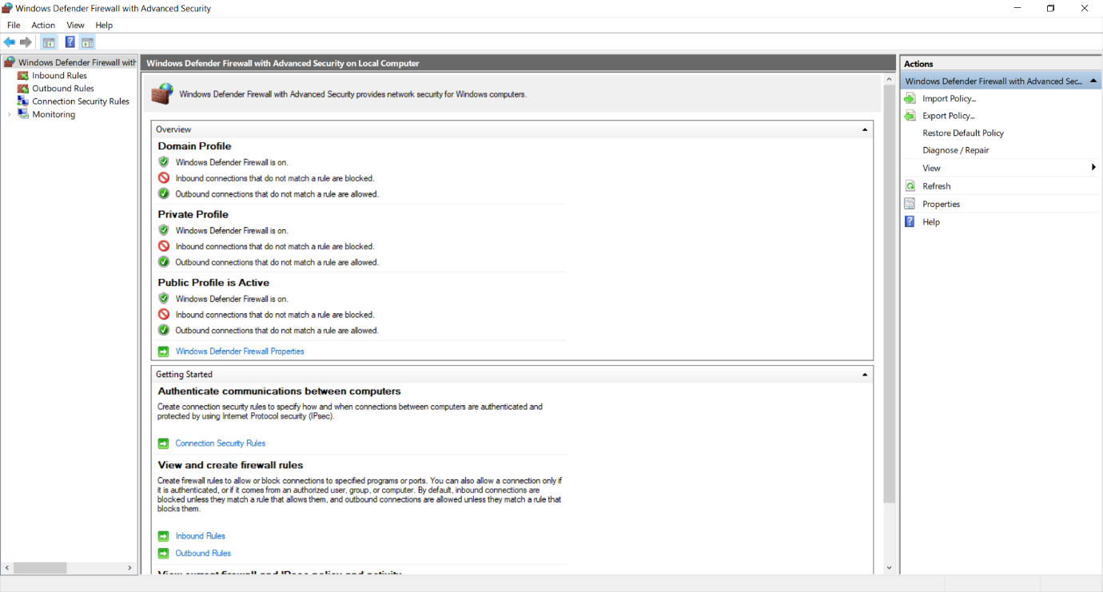

Overview of Firewall home screen

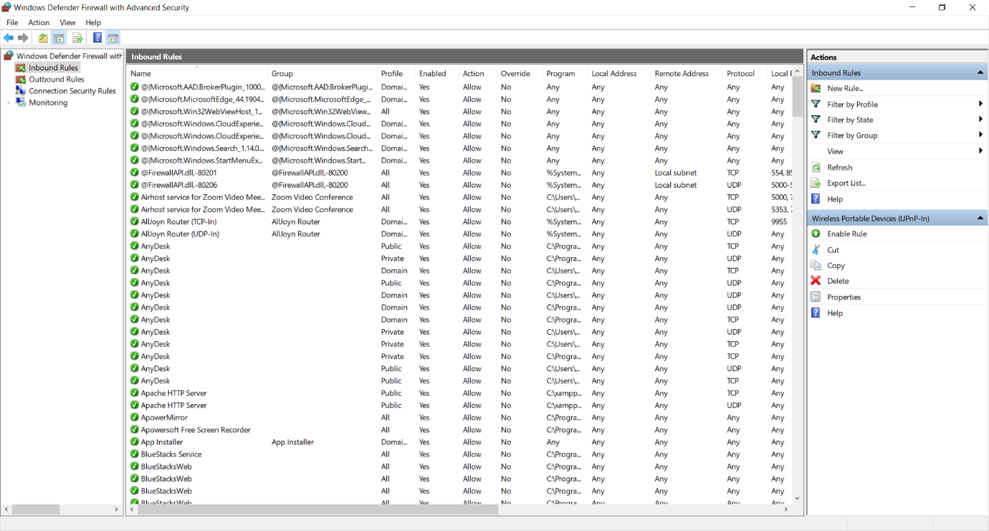

Inbound rules of firewall

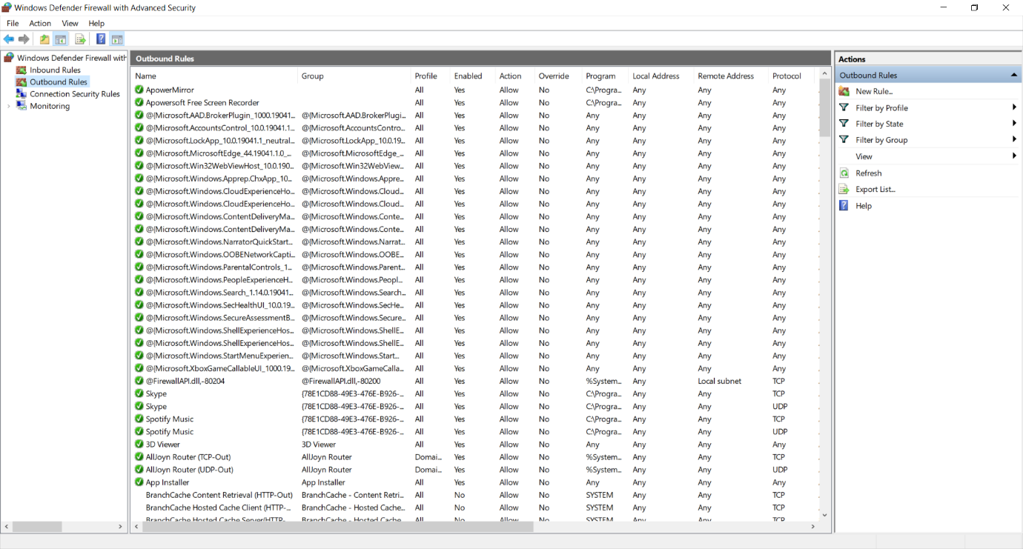

Outbound rules of firewall

1. **Describe what your windows firewall is blocking and why?**

Windows Firewall filters the traffic that goes into the computer system. It uses the predefined rules to filter incoming and outgoing traffic.

Windows firewall eliminates any harmful communication that coming to your computer from the internet or in the form of any program. It is also capable of stopping several types of [malicious program](https://tweaklibrary.com/all-about-malware/) that can put your computer’s security at stake.

1. **What happen if you turn your firewall off?**

Disabling firewall permits all traffic to entering and existing unresisted in the system. This allows not only traffic, but also malicious data that can come into the traffic. This malicious data is harmful for the window security and data in the system. If firewall is turned off and system is connected to the public network than someone can get the access the system by sending virus infected data without getting knows.

1. **Block ping command using firewall in your windows machine, also pair up with another student to verify the same.**

Here two systems are connected with the Wi-Fi on same network.

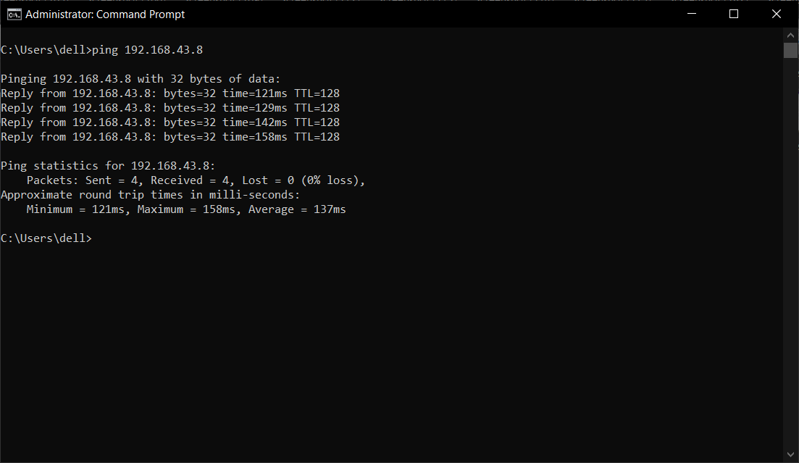

Output of ping command

In another system inbound rule is disabled.

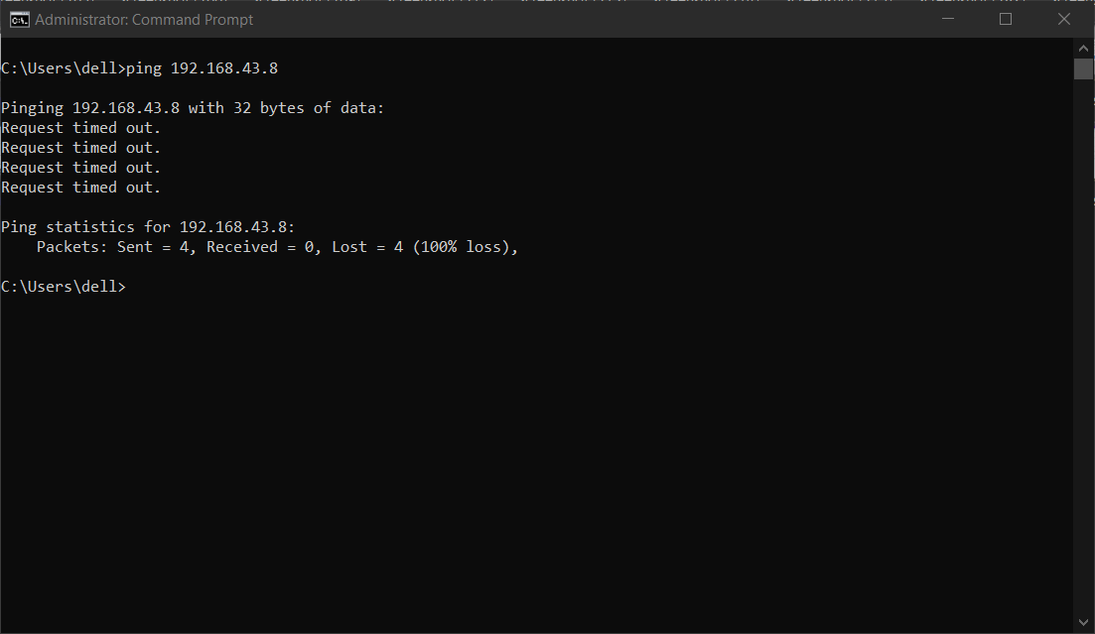

Output of ping command when inbound rule is disabled

1. **Whether a firewall is able to block some specific pages in a web application? If yes then demonstrate the same using windows firewall.**

Yes, firewall is able to block some specific pages in a web application.

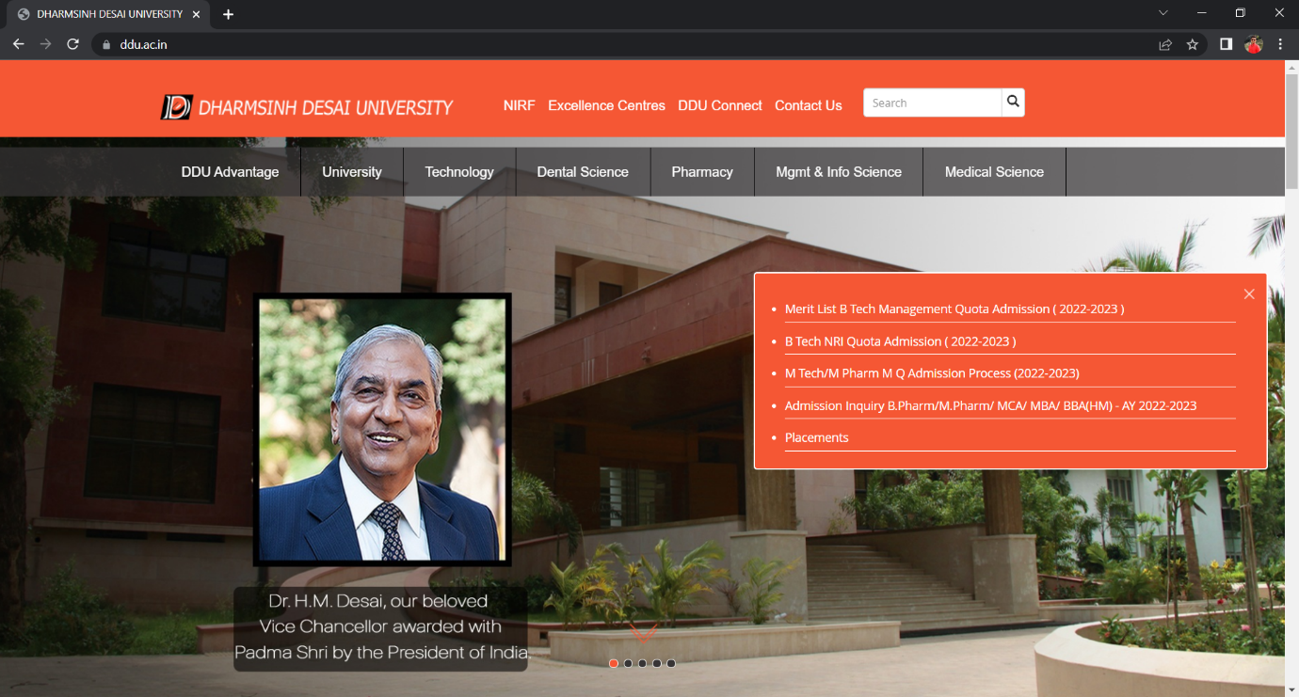

Web page of DDU website

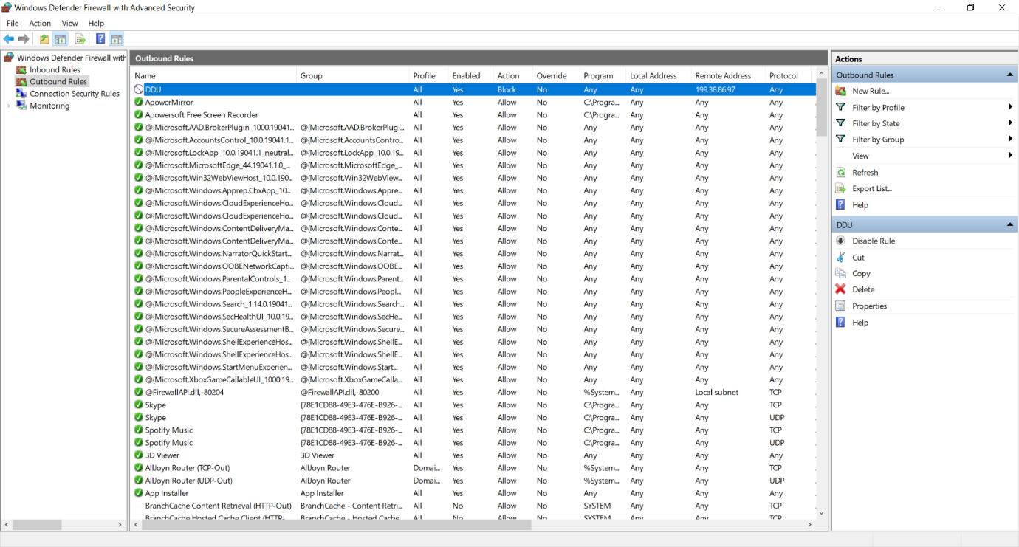

Blocked outbound rule of DDU website

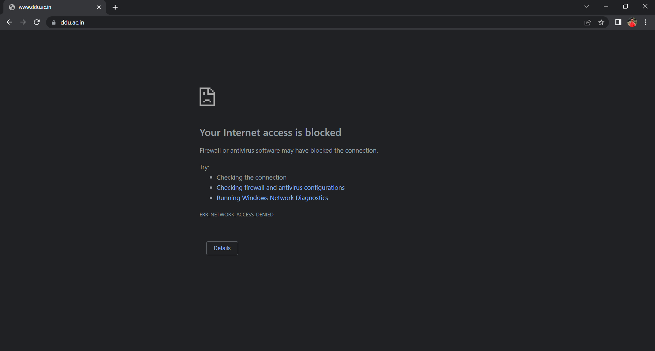

Output of blocked web page

1. **Check firewall settings in your linux machine.**

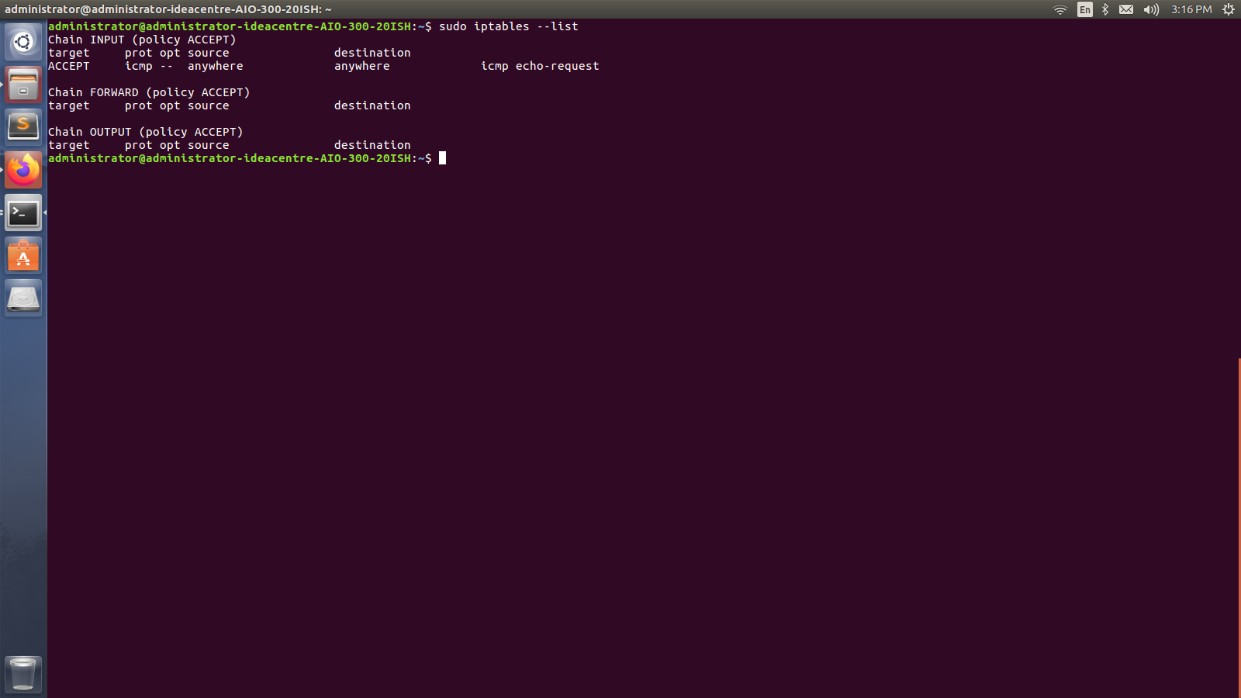

Overview of Firewall home screen

1. **Block ping command using iptables in your linux machine, also pair up with another student to verify the same.**

Here two systems are connected with same network.

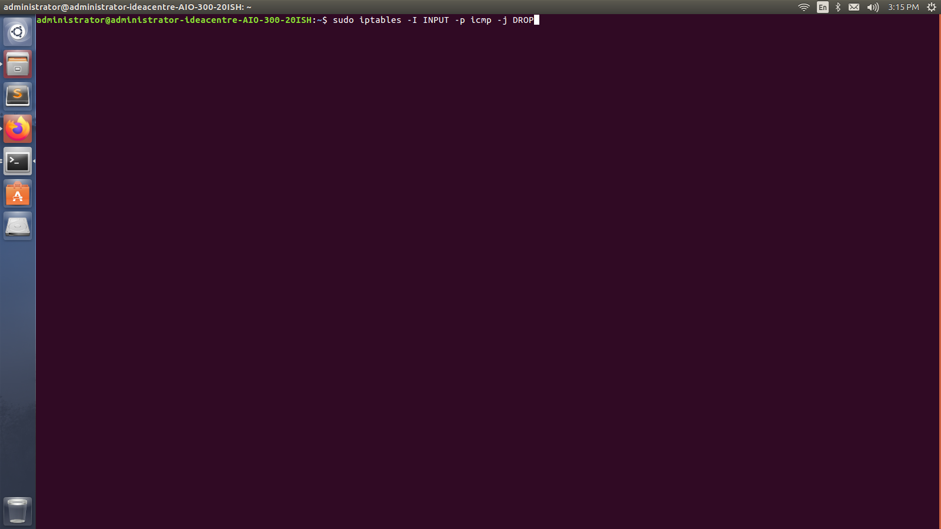

Block rule for icmp

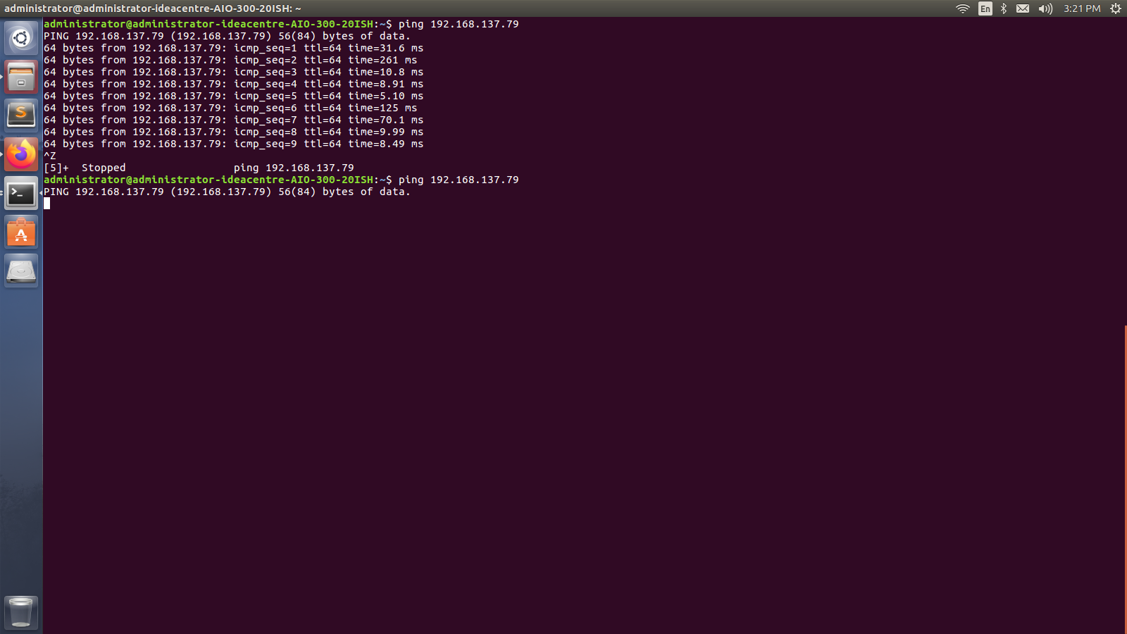

Output of ping command

In another system icmp is disabled.

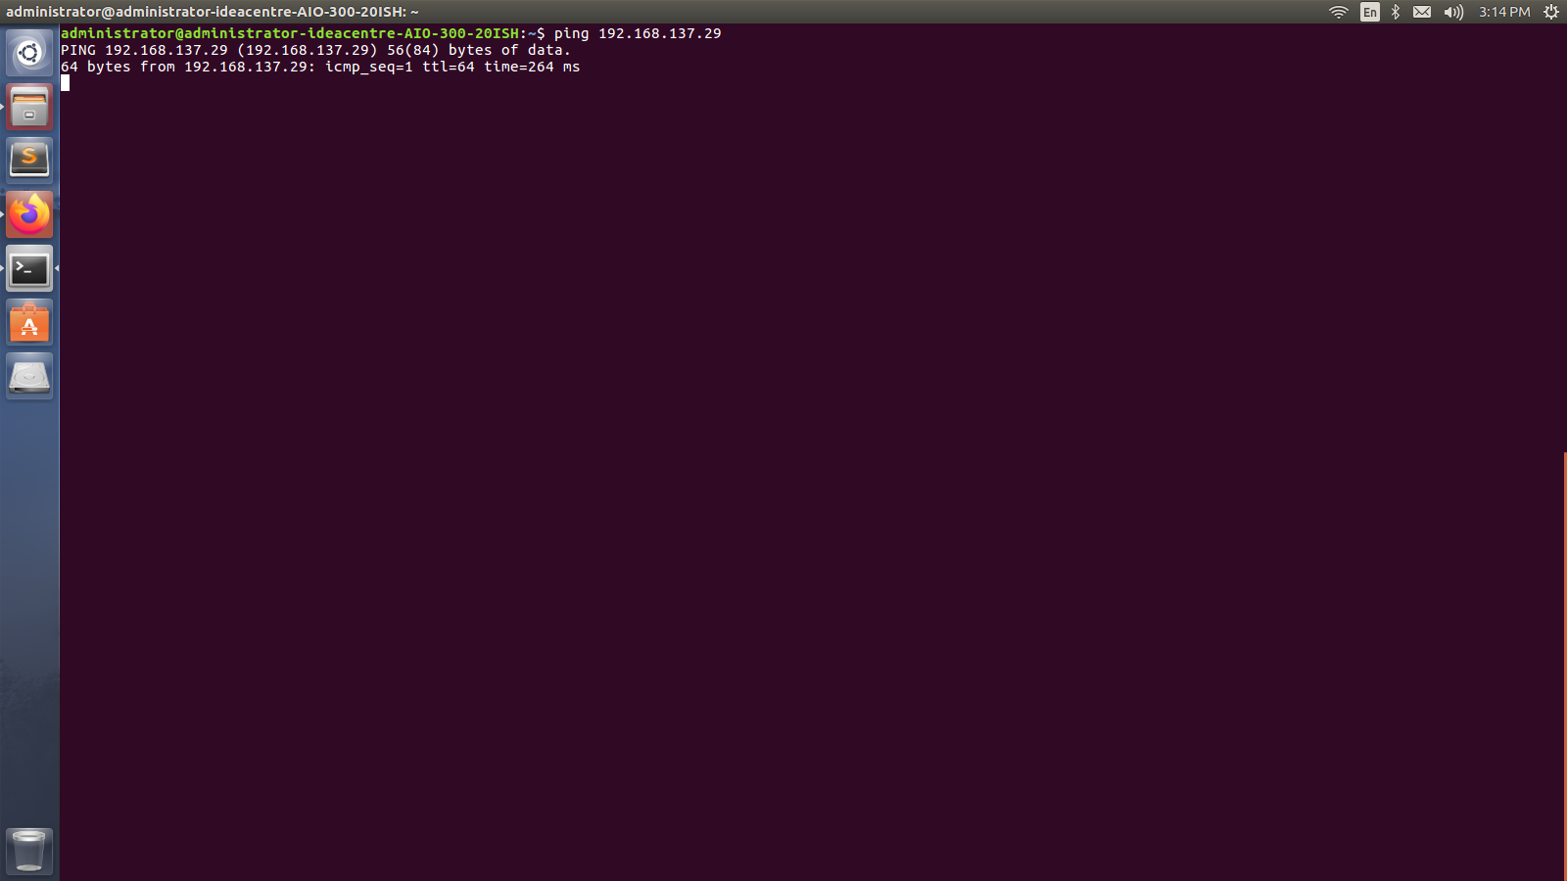

Output of ping command when inbound rule is disabled

1. **Whether an iptables is able to block some specific pages in a web application? If yes then demonstrate the same using linux iptables.**

Yes, iptables is able to block some specific pages in a web application.



Web page of DDU website

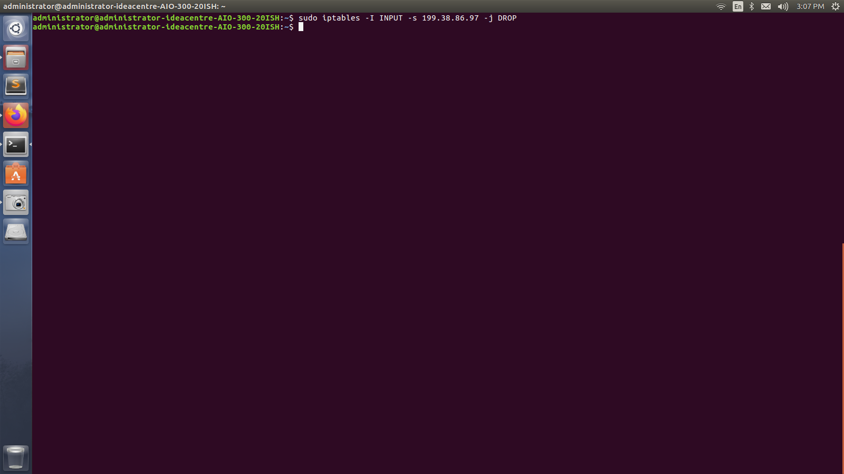

Blocked rule of DDU website

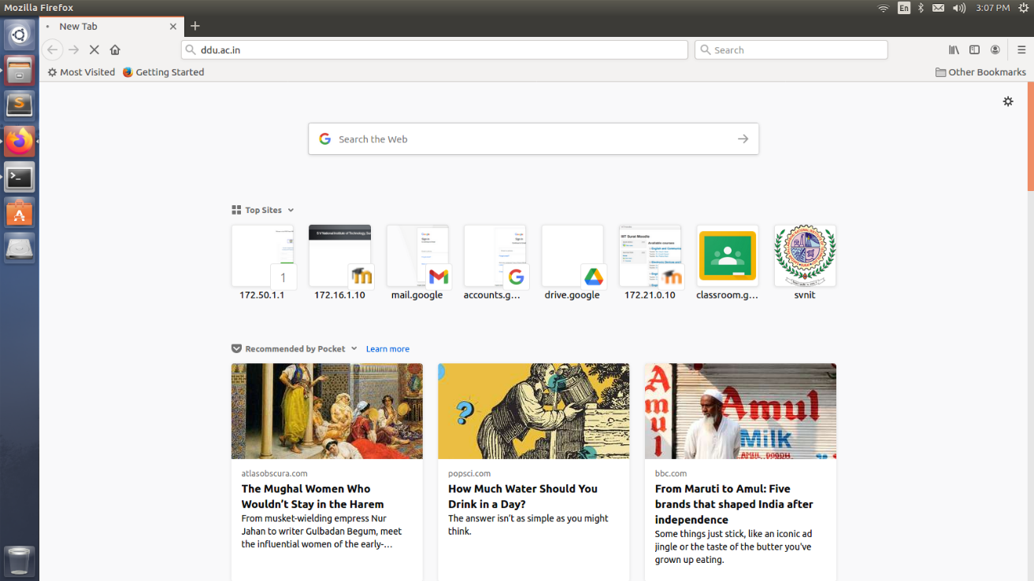

Output of blocked web page